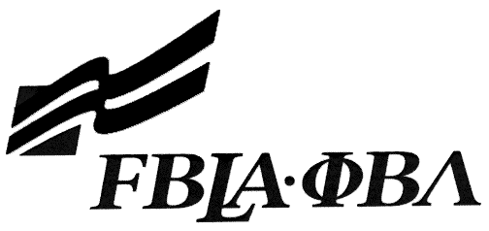 FBLA Statement of Assurance

State Event Entry Form
This form must be completed and e-mailed to the PA FBLA Executive Director at bboncal@pafbla.us.
Check one: Computer Game & Simulation Programming E-business
Desktop Application Programming Mobile Application Development
Digital Video Production Public Service Announcement
Digital Design & Promotion Website Design

Provide the complete URL for E-business, Digital Video Production, and Website Design. These events will be judged online. Make sure the URL link is valid through the National Leadership Conference.

Region: |  |  | Check One: FBLA
School:
Website URL Address: (where appropriate)
Member(s) Name:
Local Chapter Adviser Contact
Name:
Daytime/Cell Number:
School E-mail:

I/We, the undersigned, attest that the design, creation, and implementation of the event are the original work of the above chapter member(s). I/we agree that this event may be linked, promoted, and used in any way by the national FBLA-PBL, Inc. for purposes of promoting the association. (Typed name is accepted for signature)
Name of Team Member |  | Adviser’s Name
Name of Team Member |  | Name of Team Member
Complete this Document Section for the Above Events (replaces Readme file):
Software Used:
Source of Information:
Copyright Notations
Instructions for Running Project:
Template(s) Used (source)

